Campus Solutions 9.2 for Administrative Staff

Welcome to Campus Solutions 9.2! FCC’s newest version of the PeopleSoft Student Information System features a Fluid User Interface designed to work with mobile devices that can adapt the layout for a better user experience. To get you started, this guide introduces the navigation features you will use, including the Student Homepage, Banner, NavBar, and Tiles.

Logging In
In the upper right-hand corner of the FCC website, click on Faculty & Staff or use https://www.frederick.edu/faculty- staff.aspx Click on Student Records (via PeopleSoft) and log in using your current Username and Password.
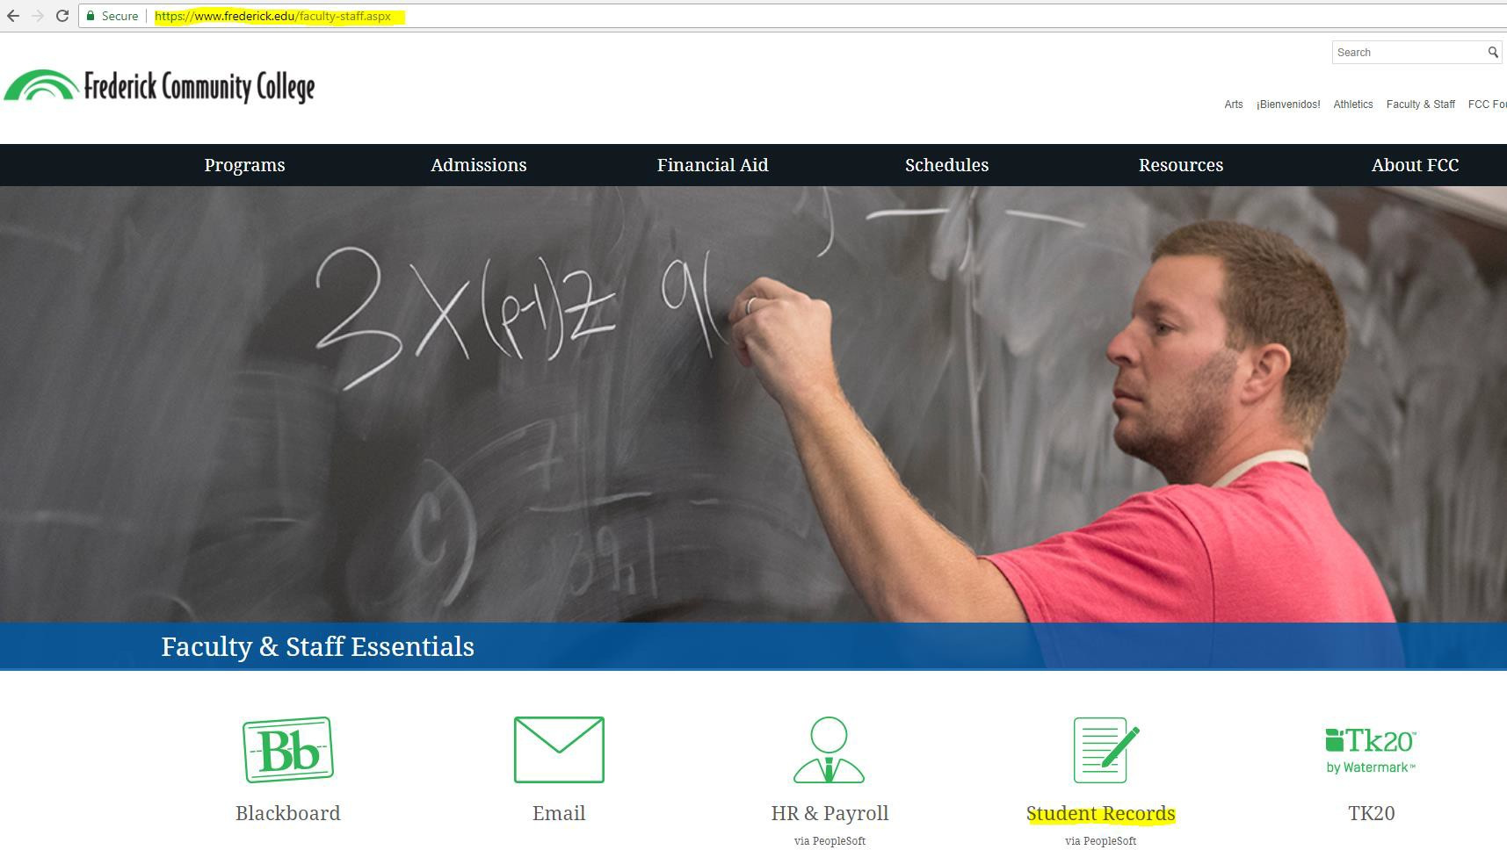

Homepages
The Campus Solutions 9.2 (CS9.2) My Homepage allows you to navigate the system using a familiar tile layout, while its responsive user interface makes it easy to use from your phone, tablet, laptop, or desktop.

Banner
A menu bar, known as the banner, is at the top of My Homepage and includes the following menu buttons:

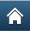
Home – click to return to your Homepage Search – do a global search to find a function

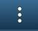
Actions List – click to see a list of actions for the current window, including Sign Out

Navigation – the NavBar slides open from the side and provides an optional way to navigate
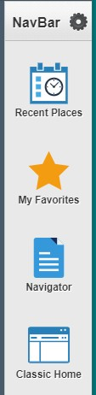
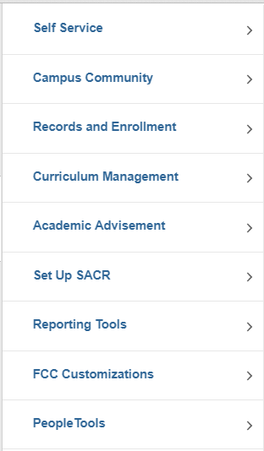
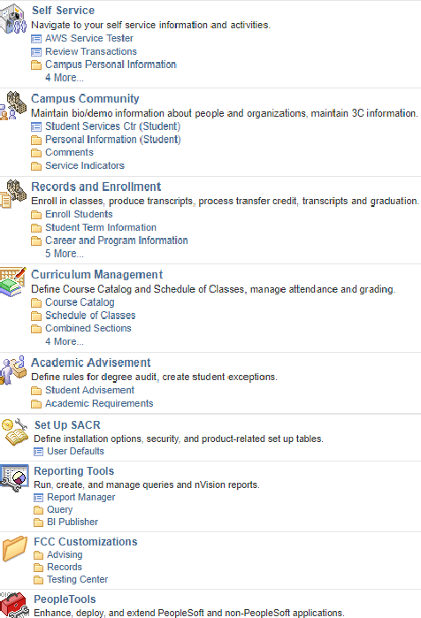
Navigator takes you to a fluid menu that will scale to your device
My Favorites allows you to save your own list of favorite places in CS9.2
Recent Places will show you the last five pages you visited
Classic Home takes you to the traditional Main Menu used in previous versions of PS

Tiles
Tiles are an easy way to navigate in CS9.2. From My Homepage, simply click on a tile to display a navigation menu giving you access to all its functions. While only a few tiles are delivered for administrative staff, My Homepage can be customized to your needs by adding additional tiles (see Personalize the Homepage section below). The How to Use your Homepage tile links to this Navigation Guide so it can serve as a quick reference while you are using your CS9.2 account.
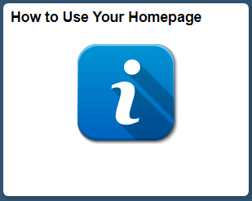

Classic Home
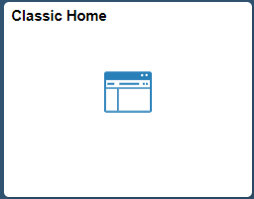
The Classic Home tile is located on both the Homepage and NavBar, giving you access to the traditional Main Menu used in previous versions of PeopleSoft. Once you click on the Main Menu, it will begin leaving breadcrumbs at the top of the page so you can see your navigation.

To switch to a new page, use the drop-downs from the breadcrumb menu. When opening a New Window, the breadcrumb menu carries over to the new page so you can use it to navigate to a new function.
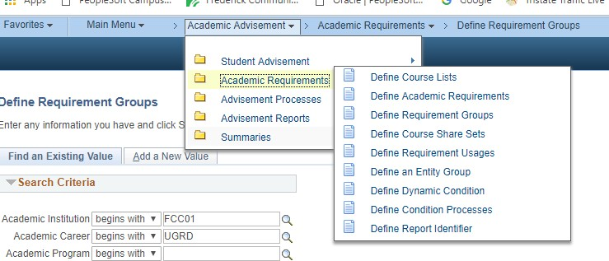

Navigation Collections
Navigation Collections are tiles that combine pages from different PeopleSoft modules (such as Academic Advisement, Records and Enrollment, Admissions) into a cross-functional menu of commonly used pages or components by specific administrative groups. Staff members will only be able to access collections and view pages to which they have security access. The current administrative Navigation Collections are listed below. These can be added to the NavBar or to your Homepage as tiles.

Personalizing the NavBar

Adding a single Page or a Folder to the NavBar
On the NavBar, use Navigator or Classic Home to navigate to the page or folder you want to add
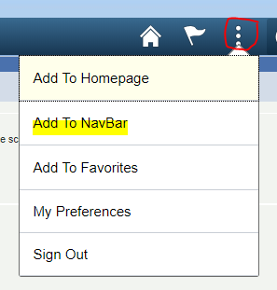
While on the page or folder you want to add, click on the Action List at the top right and select Add to NavBar
When adding a page, click OK on the confirmation box. There is no confirmation box when adding a folder. Just check the NavBar to see that it was added.
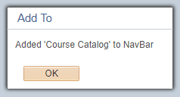

Adding a Collection/Tile to the NavBar Click on the Personalize NavBar icon
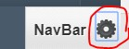

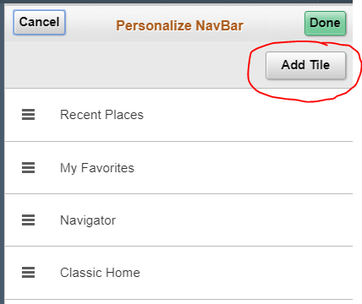
Click on Add Tile Button

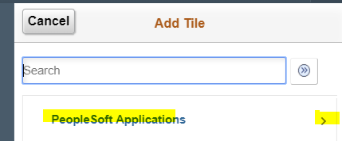
Click on PeopleSoft Applications to bring up menu options

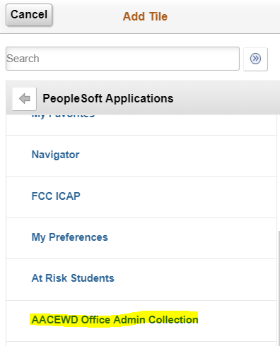
Scroll down to select the AACEWD Office Admin Collection

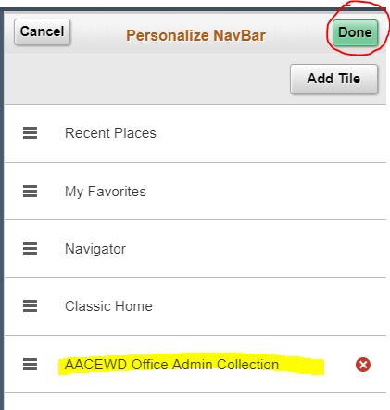
Confirm the collection has been added to your NavBar, then click Done.

Personalizing the Homepage

Adding a single Page or a Folder to your Homepage
From NavBar, use Navigator or Classic Home to navigate to the page or folder you want to add While on the page or folder you want to add, click the Action List and select Add to Homepage
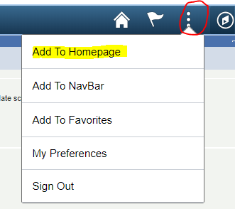

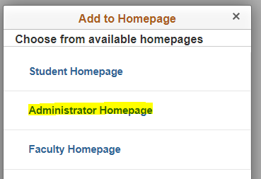
Select the homepage if you have more than one

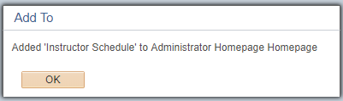
When adding a page, click OK on the confirmation box. There is no confirmation when adding a folder.

Adding a Collection/Tile to your Homepage:
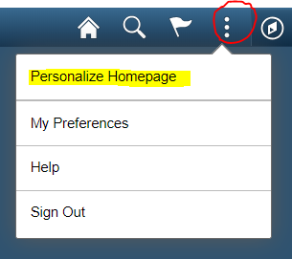
While on your Homepage, click on Action List to select Personalize Homepage

On the right side of the screen, click on Add Tile button

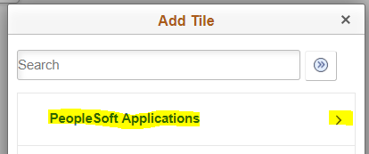
Click on PeopleSoft Applications to bring up menu options

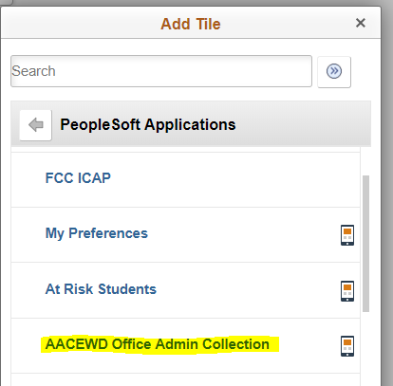
Scroll down to select the collection you want

Confirm the collection was added to the Personalize Homepage Screen. Click in the upper right corner.
NOTE: Use Personalize Homepage to remove tiles as well as change their position on the Homepage.

Mobile Navigation
When using CS9.2 on a mobile device, the banner and its menu options reduce in size with the Action List remaining available. The tiles will also rearrange and size to your device, but you will have the same access.
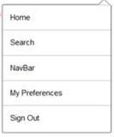
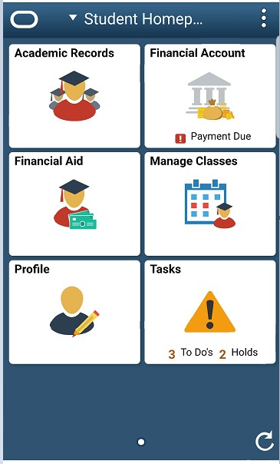

Homepage Selector
The administrative staff homepage is delivered by Oracle as My Homepage. Some administrative staff have an additional role on campus (faculty member or student); each role has a different Homepage with tiles and navigation specific to the functions of that role. To navigate between Homepages, use the center drop-down menu on the banner, called the Homepage Selector.
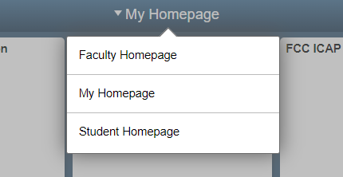

Homepage Menu – You can display the menu in Alphabetic order or Standard Order.
Click on the NavBar Settings icon
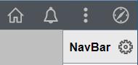-
Select Alphabetical or Standard and Save
